C:\Program Files\Microsoft Office\MEDIA\CAGCAT10\j0205582.wmfONLINE CLASSES

**ONLINE CLASSROOM EXPECTATIONS**:

* **Work Quietly and Productively**
  + Log in and get to work as soon as possible
  + Be considerate of others who are working
* **Take Care of Your Space**
  + Take your personal things with you
  + Put away headphones
  + Throw away trash
  + Push in chairs when you leave
* **Drinks at Tables Only Please**

Below are some key terms to understanding how you are doing in a course.

***Target Completion*:** The percentage of the course that should be done in order to be on track to finish the course by the course end date.

In the BLUE: You’re on target! Great job!

In the GREEN: You’re ahead! Even Better! You may work on other class assignments, read, etc.

In the RED: You’re behind! You need to do work outside of class!

***Completion %*:** The percentage of the course that has been completed.

***Overall Grade*:** The grade you’ve earned on the portion of the course you’ve completed.

***Actual Grade*:** Based on the overall grade in relation to the % of coursework completed vs. the percentage of coursework that should have been completed. It is what the grade would be if any “missing” assignments are recorded as “0’s”. In this case, “missing” assignments are any assignments a student is behind on.

In PowerSchool, it will be the ***Actual Grade*** that gets recorded. If a student is “On Track” or “Ahead”, the *Actual Grade* and the *Overall Grade* are the same. However, the more “Behind” a student is in the class the lower the *Actual Grade* will be.

**INFORMATION FOR PARENTS**

There are a couple of ways for parents to see a student’s progress, and the attached page has additional details on each. The first way is to sign-up to receive Daily or Weekly emails of your student’s progress. Information on how to do this is below.

The second way is called *The Family Portal*. *The Family Portal* is a site that allows parents access to current information about their student’s progress and performance. Parents will be able to see a range of information such as how much time the student has spent working on their courses, what their grades are, and if they are on track to finish their courses on time. *The Family Portal* can be accessed at <http://learn.edgenuity.com/family/>. If you would like to sign up for this, you will need to contact us directly so we can provide you with an access code to use in the registration process.

To get signed up for either of the ways above,

**SEND AN EMAIL to** [**lwolfe@vcs-k12.net**](mailto:lwolfe@vcs-k12.net) **or** [**aslezak@vcs-k12.net**](mailto:aslezak@vcs-k12.net)**.**

For the SUBJECT of the email, please type **PARENT REQUEST!**

In the email, include the following information:

1. Your child’s name
2. Your name
3. Your email address
4. The frequency with which you’d like to receive the progress report (daily, weekly)
5. If there is a 2nd parent that would like information, you can include their name and email as well.
6. Also, tell me if you would like an “access code” to be able to use “*The Family Portal*”

If you do not have email and wish to speak with your student’s online teacher, please call the high school office at 989-268-5343.

Lastly, if your student needs ADDITIONAL TIME and cannot work on their class outside of school or wants extra help, PLEASE, PLEASE, PLEASE have them make arrangements to stay after school. The days that work change from week to week but we can always make something work. Thanks for your help in helping your student succeed!!!

**Edgenuity Online Classes**

**Understanding the Progress Report**

Students also see this same progress report each time they log into the Virtual Classroom to perform work in their courses. Edgenuity is dedicated to ensuring that students, as well as the parents, guardians, and educators who support them, always know how they are performing in their course work.

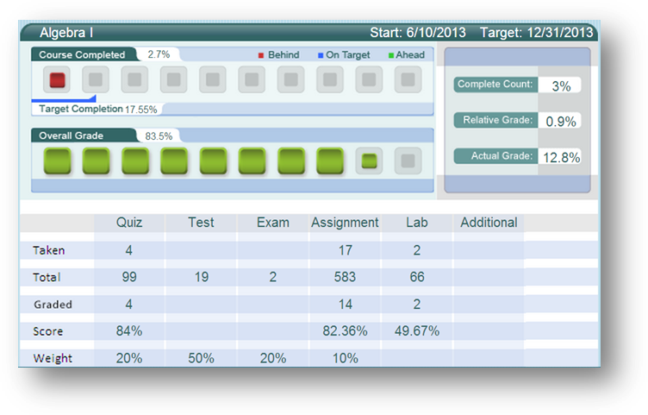

**NAME OF COURSE:** At the top of the report you will see the name of the course.

**COURSE COMPLETED:** There are three elements in the Course Completed section that advise you on the progress your child is making in that specific course:

1. **Course Completed percentage:** Indicates the percent of the course completed, calculated by the number of assignments completed vs. the total number of assignments in the course weighted by the average time it takes a student to complete the types of assignments.
2. **Color coded completion squares:** Indicate what the colors in the square blocks just below the Course Completed percentage represent:
   * **Red**: Your child is falling behind in the course
   * **Blue**: Your child is on track with the course
   * **Green**: Your child is ahead of schedule in the course
3. **Target Completion:** Indicates how far along in the course the student should be.

**OVERALL GRADE:** The grade your child has earned thus far in the course, based on all activities and assessments he or she has completed:

1. **Overall Grade percentage:** Percentage grade based on a 0%–100% scale.
2. **Color coded grade squares:** Quick-reference colors to indicate what your child’s grade is in the course(s):
   * **Red**: Indicates a grade between 0%–59%
   * **Orange**: Indicates a grade between 60%–69%
   * **Yellow**: Indicates a grade between 70%–79%
   * **Olive**: Indicates a grade between 80%–89%
   * **Green**: Indicates a grade between 90%–100%

**COMPLETE COUNT:** Indicates the percent of the course completed, calculated by the number of assignments completed vs. the total number of assignments in the course (this number may be slightly different than the Course Completed percentage).

**RELATIVE GRADE:** Represents the grade that your child would receive if he or she stopped working in that course today and received 0% for all unfinished activities.

**ACTUAL GRADE:** Based on the overall grade in relation to the percentage of coursework completed vs. the percentage of coursework that should have been completed. This will not populate unless a start date and target date have been set.

**TARGET COMPLETION:** This is the percentage of the course the student should have completed based on the start and target dates set by the teacher.

**TAKEN:** This shows the number of activities, by category, completed by the student.

**TOTAL:** This shows the number of activities, by category, assigned in the course. Please note that this figure may not be accurate if pre-testing is enabled for the course as the pre-test results will determine the number of activities presented to the student.

**GRADED:** This shows the number of activities, by category, that count toward the student’s grade. By default, activities such as Vocabulary and Lectures do not factor into the grade; this is why the Graded number is lower than the Taken number.

**SCORE:** This shows the average grades for each type of activity that the student has completed.

**WEIGHT:** This shows how the grade values of the different activity categories combine to form the overall grade.

## Edgenuity Online Classes

## Family Portal Introduction

The Family Portal is a site that allows parents access to current information about their student’s progress and performance. Parents will be able to see a range of information such as how much time the student has spent working on their courses, what their grades are, and if they are on track to finish their courses on time.  
The Family Portal can be accessed at <http://learn.edgenuity.com/family/>

## Family Portal Setup and Use

## The Family Portal feature must be enabled by your student’s teacher/admin. An access code will be provided to you by the teacher/admin to use in the registration process.

Once you receive the email below, you can start the registration process.

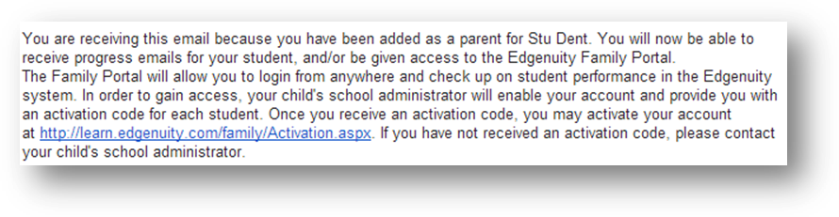

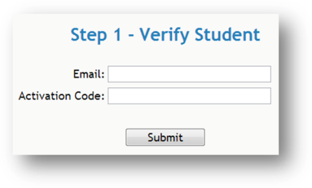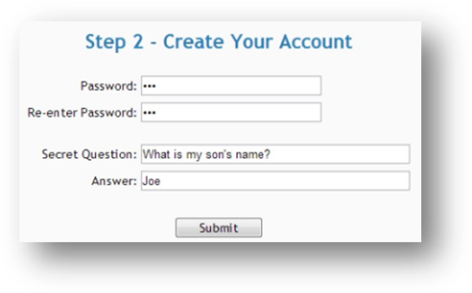Clicking on the **link** in the email will begin the registration process. At this point, you will be prompted to enter in the email address where you received the notification email, along with the activation code you were provided by the teacher/admin.

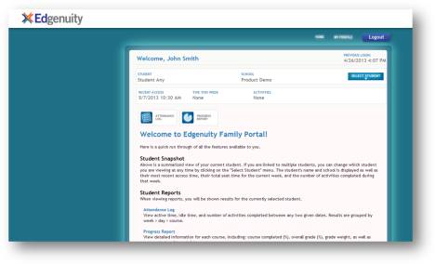With the account now generated, you will automatically be logged into the Family Portal. Once you are logged in, you will be able to see a listing for all students that are associated with your account. You will also have the ability to view the Attendance Log and/or Progress Report for any of your associated children.

The Family Portal site contains explanations for all of the information you’ll be able to find, such as the attendance log, progress reports, and more, so that you can understand all the details about how your student is doing.

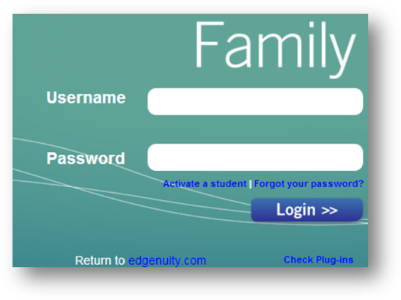

## Logging into the Family Portal

When you return to the Family Portal at<http://learn.edgenuity.com/family/>, you can log in using your email address and the password you created. If you have trouble remembering your password, you can click the **Forgot your password?** link, enter your email address, and your password will be emailed to you.

**EDGENUITY STUDENT CONTRACT**

By signing below, I am stating that I have read and understand the expectations as given for Edgenuity Online Classes. By following these, I should be able to have success with my online coursework. I am indicating that I accept and agree to abide by the terms, outlined requirements, and rules listed here. I also understand that if I disregard any part of this agreement, I risk progressive disciplinary action.

* I agree to all of the behavioral expectations and consequences as outline by the teacher and in the school handbook.
* I agree to protect my username and password. I will not share my log in information with others.
* I understand that all of my notes/work must be kept in order in a notebook. Taking notes is a requirement, and I understand I will be allowed to use them on quizzes and tests.
* I understand that I am required to use headphones to listen to the instructional videos.
* I will be present and punctual to class. I will work diligently on my online course in order to complete it by the end of the semester. Appropriately, I will use access at the school, public library and/or within my home.
* I understand that I am to be quiet, non-disruptive, productive, and steadily working on my Edgenuity course during class.
* I agree never to submit work that is not my own and never to cheat on assignments or assessments. I understand that such activities violate our school’s honor code and can result in suspension or expulsion.
* I accept that my teacher holds the rights to log me off, give me additional activities, and/or make me redo activities if they deem it necessary or beneficial to me.

Should you have any questions or concerns throughout the year, you may contact me by phone at 268-5343 by email at [lwolfe@vcs-k12.net](mailto:lwolfe@vcs-k12.net) or [aslezak@vcs-k12.net](mailto:aslezak@vcs-k12.net).

To help us communicate with you better, please also give the BEST phone number and time at which to contact you and also an email address if you have one would be great. Thank you in advance for this information.

______________________________ ______________________________

Parent Signature Student Signature

______________________________ ___________________

Parent Email Address (Please PRINT) Date

______________________________ ________________________________________________

Parent Phone Number and best time to call this number (mornings, afternoons, anytime, etc.)

Does your student have access to the internet access outside of school? _______ Yes _______ No

If so, through what type of device(s)? _____ Cell Phone _____ I-Pod

_____ Tablet _____ I-Pad

_____ Laptop _____ Desktop Computer

_____ Public Library _____ Other_______________________